Source https://www.getyourguide.com/barcelona-l45/from-barcelona-montserrat-half-day-tour-liquor-tasting-t382639?ranking_uuid=bc34fc37-69dd-4d4d-b10e-6774604fe938&date_from=2024-01-25&_pc=1,1
__________________________________________________________

Montserrat Magic Escape: Scenic Monastery & Wine Experience from Barcelona
__________________________________________________________
★★★★★ 4.7/5 20 reviews

Add to wishlist ♡

__________________________________________________________

5–9 hours | €75 per person

🏕  Image | 🏕  Image | 🏕  Image | 🏕  Image | 🏕  Image | 🏕  Image

__________________________________________________________
About This Tour
Escape the city and journey into Catalonia’s most breathtaking mountain landscape on this unforgettable Montserrat experience from Barcelona. Discover the dramatic multi-peaked Montserrat range, explore its legendary monastery, and admire historic artworks inside the sacred complex. Choose from flexible tour durations, with optional winery visits, tapas tastings, or gourmet lunches that add a delicious local touch to your mountain adventure.
__________________________________________________________
What’s Waiting for You
- Duration: 5–9 hours (depending on option selected)
- Group Size: Up to 70 on transport, guided groups up to 20
- Languages Available: English
- Guide: Professional live guide
- Transportation: Air-conditioned bus + cogwheel train
- Meeting Point: Carrer d'Alí Bei, 80, Barcelona (Barcelona Nord Bus Station, Section B)
- Season: Available year-round
__________________________________________________________

Check Dates & Availability

Select participants: (Age 99 and younger) - 1 +

Choose date:
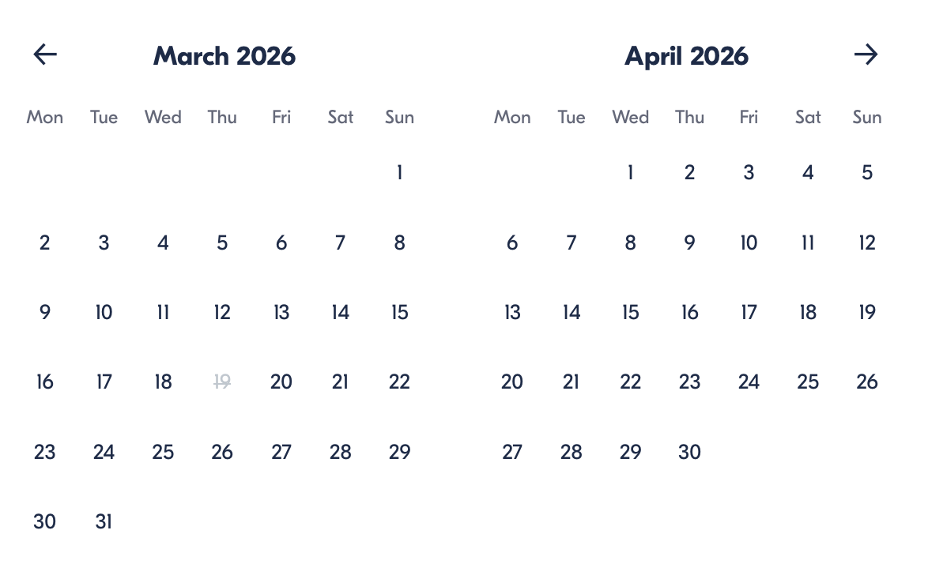

Check Availability

opens:

Participants: 1 March 16, 2026

Montserrat Magic Escape: Scenic Monastery & Wine Experience from Barcelona

- Duration: 5 hours
- Offered in: English
- Starts at: 9:45 AM

Cancellation:

- More than 24 hours before start — Full refund
- Less than 24 hours before start — No refund

Price breakdown: 1 Participant x €75

Total: €75

The total price includes all taxes and fees.

Add to cart Book now

__________________________________________________________
Tour Features
- Montserrat Mountain Range: Witness Catalonia’s iconic jagged peaks and dramatic landscapes.
- Cogwheel Train Ride: Scenic ascent with panoramic mountain views.
- Historic Abbey Visit: Guided exploration of Santa Maria de Montserrat Monastery.
- Free Exploration Time: Discover hidden viewpoints, trails, and cultural highlights.
- Wine & Culinary Upgrades: Optional winery visit with tastings, tapas, or multi-course lunch.
__________________________________________________________
Detailed Itinerary

Departure from Barcelona
Meet your guide at Barcelona Nord Bus Station and board your comfortable coach for a scenic drive into the Catalonian countryside. Sit back and enjoy the changing landscapes as the famous Montserrat mountain range rises dramatically in the distance.

Cogwheel Train Ascent
Transfer to the charming cogwheel train for a picturesque climb up the mountainside. As you ascend, the spectacular peaks of Montserrat unfold around you, offering unforgettable photo opportunities.

Guided Monastery Tour
Arrive at Santa Maria de Montserrat Abbey, an active monastery dating back to the 11th century. Join your guide for an immersive walking tour exploring its fascinating history, architecture, and spiritual significance.

Free Time Exploration
Enjoy around 1.5 hours to explore independently. Options include:
- Reserving a time slot to see the Black Madonna
- Visiting the Montserrat Museum (featuring works by Picasso, El Greco, and Dalí)
- Taking a funicular ride for panoramic views
- Walking scenic trails

Optional Winery Experience (Full-Day Options)
Guests who choose extended tours continue to a boutique winery set amid mountain scenery. Here you can stroll through vineyards, learn about winemaking traditions, and enjoy tastings of regional wines paired with tapas or a multi-course lunch, depending on your selected package.

Return to Barcelona
Relax during your comfortable return transfer, arriving back in the city with unforgettable memories of Montserrat’s beauty, culture, and flavors.
_________________________________________________________
Included in Price
- Transportation by air-conditioned bus
- Cogwheel train ticket
- Guided walking tour
- Entry to Montserrat Monastery
- 1.5 hours free time
- Wine tasting (full-day options)
- Tapas lunch (7-hour option)
- Multi-course lunch (9-hour option)
__________________________________________________________
Not Included
- Museum entry
- Black Madonna entry ticket
- Funicular ticket
__________________________________________________________
Who Should Avoid This Tour
- Guests unable to walk moderate distances
- Travelers bringing large luggage or strollers
- Visitors with severe mobility limitations (contact the provider before booking)
__________________________________________________________
Important Trip Info
- Comfortable footwear and weather-appropriate clothing are recommended.
- Temperatures in Montserrat may differ from those in Barcelona.
- Basilica entry may be restricted on Sundays or during religious events.
- Black Madonna visits may require additional ticket purchase and wait time.
- Infants aged 3 or under join free (no baby seats provided).
__________________________________________________________

Cancellation Policy
- More than 24 hours before start — Full refund
- 24 hours or less before start — No refund
__________________________________________________________
What Our Clients Are Saying

Overall rating  4.7/5  ★★★★★  Based on 20 reviews | Review summary  Guide 4.5/5  Transportation 4.6/5  Service 4.7/5  Organisation 4.5/5

Filter  - All traveller types  - Couples  - Group of friends  - Families  By star rating  - All star ratings  - 5 stars  - 4 stars  - 3 stars  - 2 stars  - 1 star | Search reviews (e.g., guide)  Sort by:  - Top picks  - Latest reviews  - Best ratings  - Lowest ratings
__________________________________________________________
★★★★★
Olivia S. — United Kingdom
Montserrat was absolutely breathtaking. The guide made the experience engaging, and the winery visit was a fantastic bonus.
★★★★☆
Emily C. — Canada
Beautiful scenery and a knowledgeable guide.
★★★★☆
Luca R. — Italy
Great tour overall with stunning views. The winery experience was lovely.
See more reviews
__________________________________________________________

Meta tags

Page - Montserrat Magic Escape: Scenic Monastery & Wine Experience from Barcelona

Title: Montserrat Magic Escape: Scenic Monastery & Wine Experience from Barcelona | Travellio Global

Description: Discover Montserrat’s breathtaking mountains, historic monastery, and optional winery experience on a scenic guided tour from Barcelona. Flexible durations available.

H1 - Montserrat Magic Escape: Scenic Monastery & Wine Experience from Barcelona
__________________________________________________________

